**GOVERNMENT ARTS COLLEGE, DHARMAPURI-636 705.**

**DEPARTMENT OF ELECTRONICS & COMMUNICATION**

**AFFILIATED TO PERIYAR UNIVERSITY**

**2023-2024**



**NAANMUDHALVEN PROJECT REPORT**

**Submitted in Partial Fulfilment of the Requirements for the Degree**

**of**

**B.Sc., ELECTRONICS & COMMUNICATION**

**Submitted to**

**Periyar University, Salem-636 011**

**BY**

**1.ARUL M C21UG105ELC004**

**2.SIVASATHI R C21UG105ELC026**

**3.KARTHICK C C21UG105ELC011**

**4.MURUGAVEL V C21UG105ELC015**

**Analysing Housing Prices in Metropolitan Areas of India**

**House price prediction in a metropolitan city in India is a valuable solution for potential home buyers, real estate agents, and investors. By leveraging historical sales data, property details, and location-specific information, a predictive model can accurately estimate house prices. The model's scalability, real-time updates, user-friendly interface, and transparency ensure it meets the needs of stakeholders. Integration capability, data privacy, and costeffectiveness are also important considerations. By addressing these requirements, the prediction model provides reliable insights, empowering stakeholders to make informed decisions in the fast-paced real estate market.**

**PURPOSE:**

**The technical architecture involves leveraging the data analytics capabilities of Tableau for visualizations and analysis. The architecture comprises several components to ensure efficient data processing and visualization.**

**At the core of the architecture is the data infrastructure, which includes data sources such as market reports, economic indicators, and surveys conducted among iPhone users in India. These data sources are collected and stored in a structured format for further**

**analysis. Tableau is used as the primary data visualization tool. It connects to the data sources and allows for data extraction, transformation, and loading (ETL) processes. Tableau's intuitive interface en…**

**EMPATHYMAP:-**

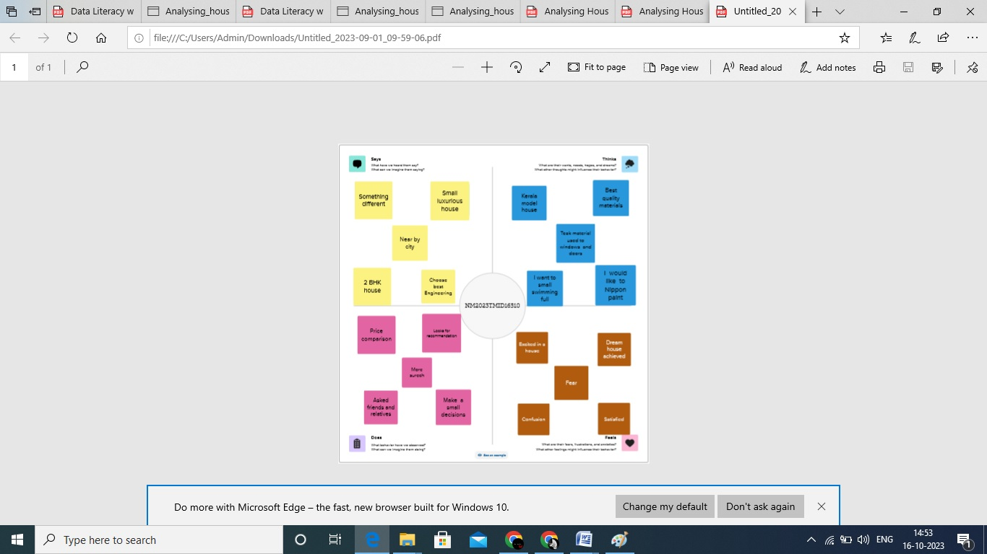

**BRAINSTROMING AND EMPATHY MAP:-**

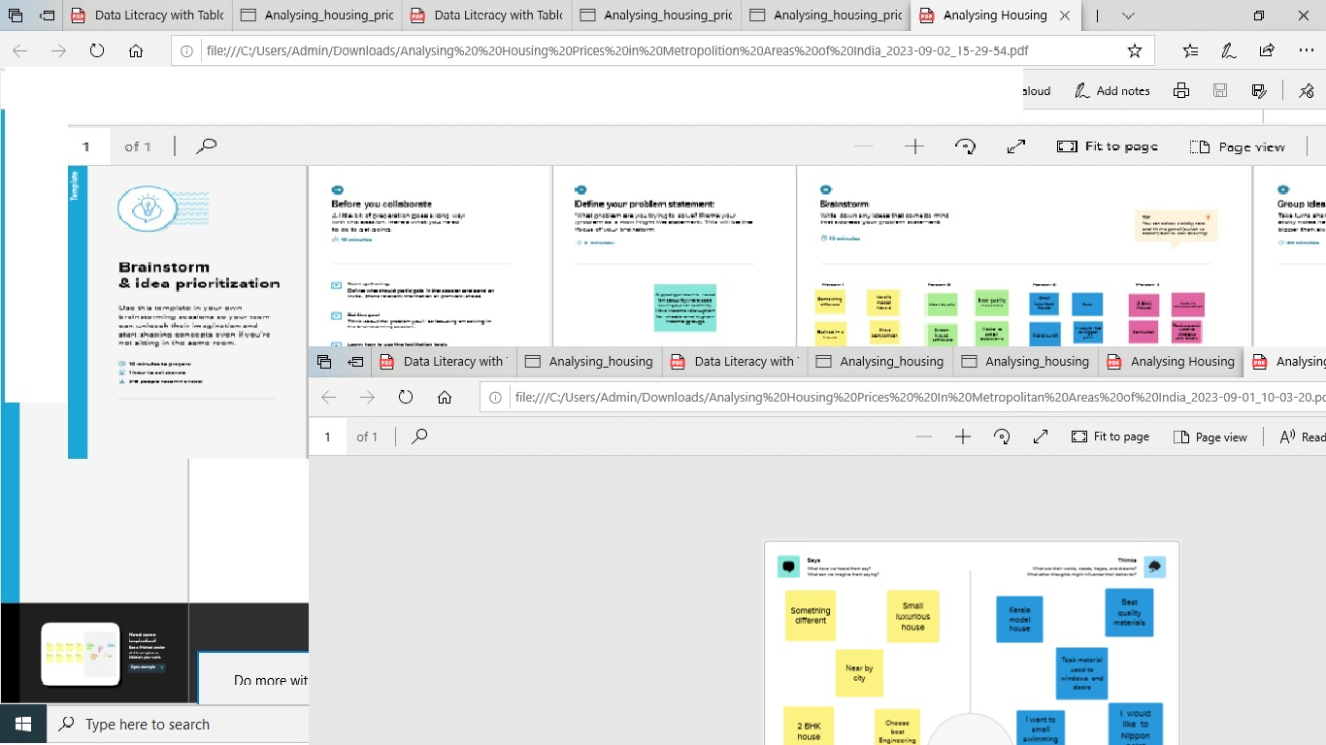

DASHBOARD:-

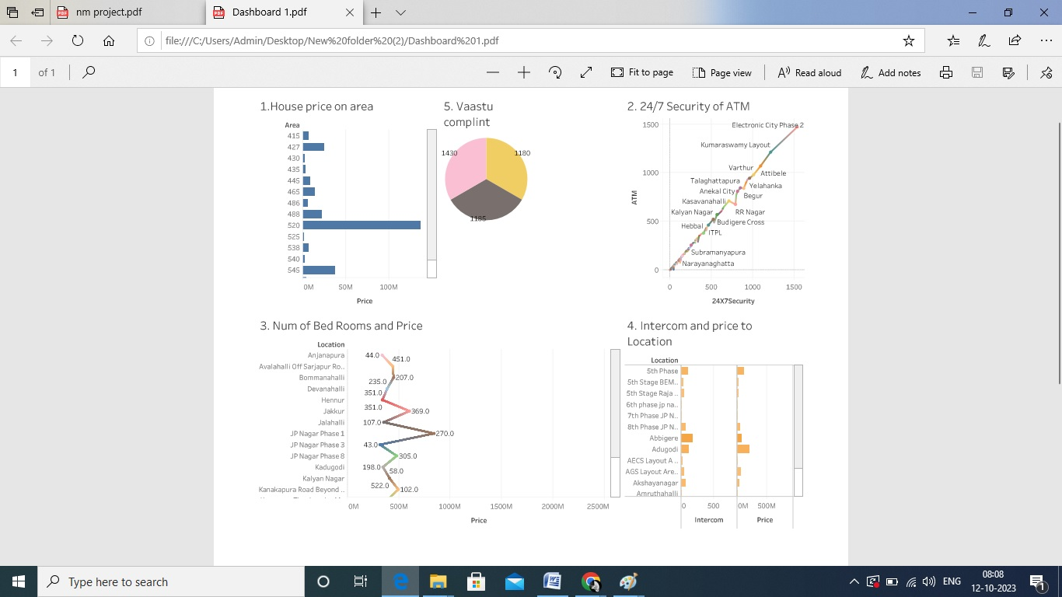

STORY :-

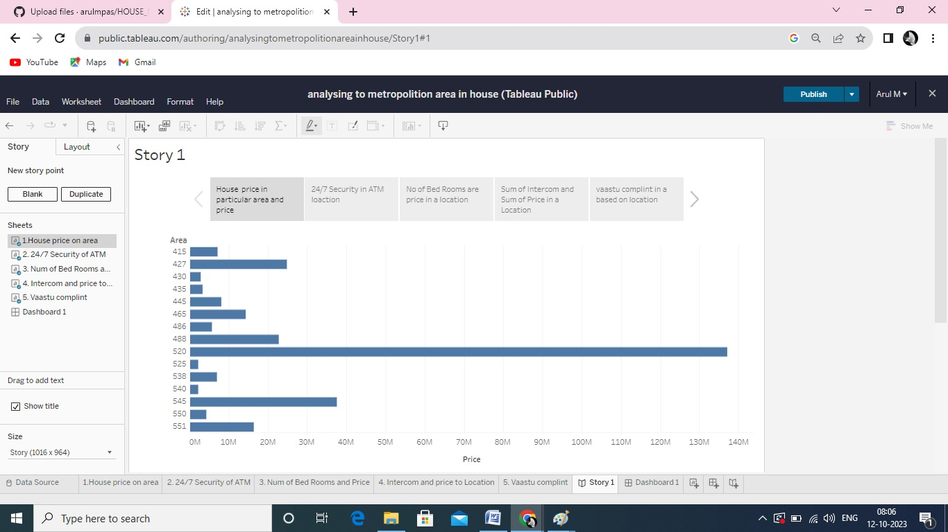

ADVANTAGE &DIS ADVANTAGES:

House price prediction can help the developer determine the selling price of a house and can help the customer to arrange the right time to purchase a house. There are three factors that influence the price of a house which include physical conditions, concept and location.

Conclusions :

This paper analyzes whether the Law of One Price (LOOP) holds in the housing market of fifteen metropolitan areas in India, namely Delhi, Mumbai, Bengaluru, Kolkata, Chennai, Jaipur, Lucknow, Hyderabad, Pune, Surat, Ahmedabad, Patna, Faridabad, Kochi and Bhopal. We test the existence of LOOP using the Im, Pesaran and Shin (2003) panel unit root test based on quarterly data on residential property prices covering the period of 2007Q1 to 2011Q4 of the Indian housing market. Based on the criterion of price convergence, house prices in the 15 metropolitan cities do not converge to the LOOP. This implies that the housing markets in the different areas operate as segmented independent local markets. Therefore, house prices in one location in India cannot impose a competitive constraint on house prices in other location, and as such a home owner can freely set the price of his house.